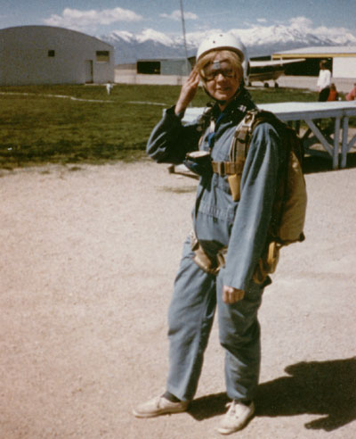
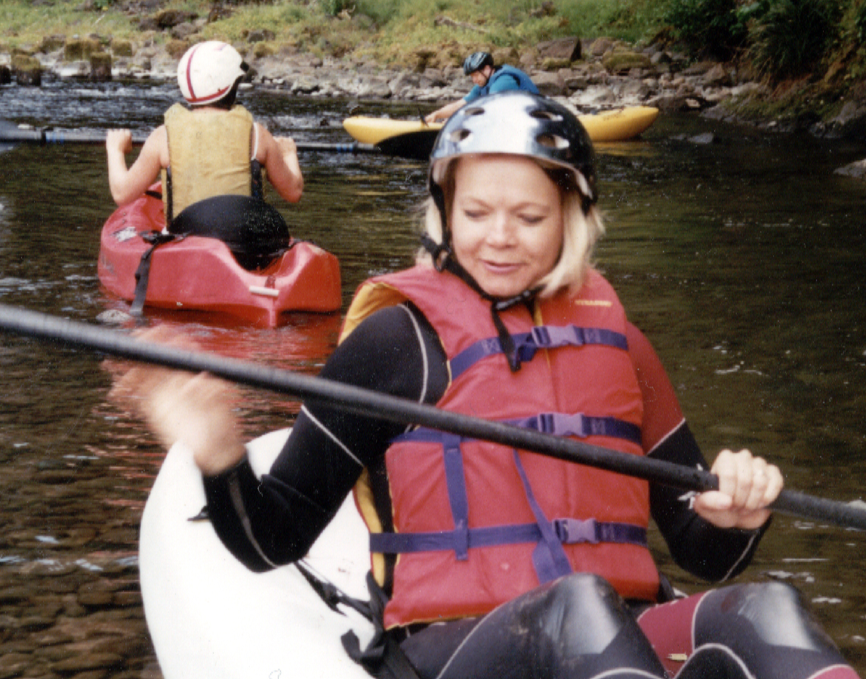
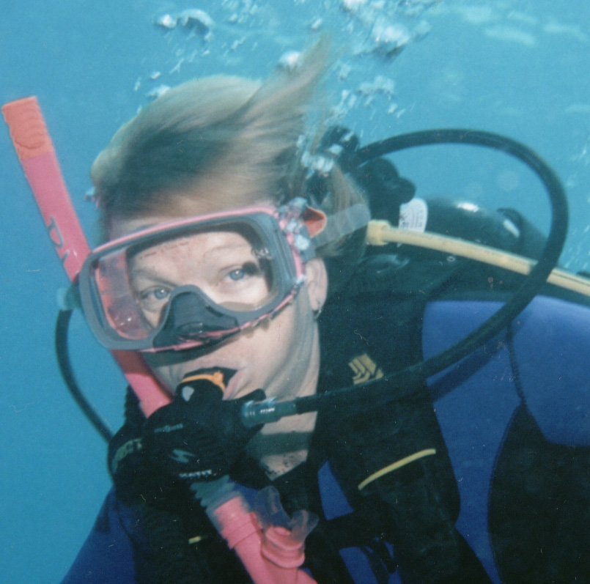
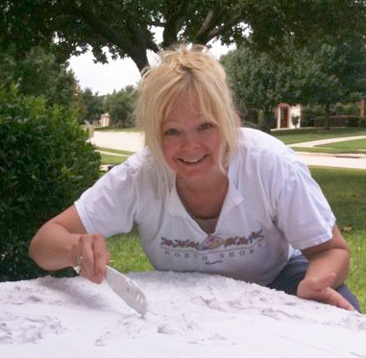
Anita Robbins is known for her highly textural renditions of nature that combine sculpture and painting. Her work is generous in color, paint and texture. Dynamic lighting and the illusion of 3-D are distinctive qualities of her work.

Robbins received a Bachelor of Arts degree from Brigham Young University. She teaches workshops and private lessons. Robbins’ artwork has won numerous awards including:
- Springville Musuem Spring Salon, 241 works accepted out of 942, 'Evolution'
- First Place in the Intermountain Autumn Show , 'Leaf with droplets'
- Excellent for the Utah County Fall Show 'Peonies -n- Pears'
Her students placed highest honors at the Texas State Fair the last three years, including two Best of Show awards.

Robbins does book cover illustrations for Covenant Publishing and corporate commission work for Flowserve and Great Wolf Lodge.
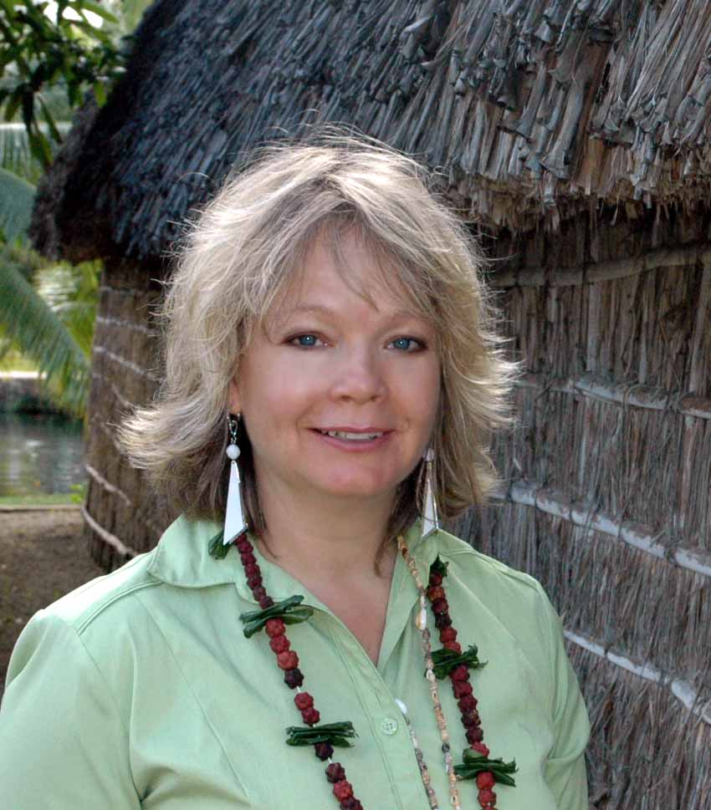
Robbins has exhibited at these fine art galleries across the United States and is in private collections around the world.
- The Young at Art Gallery, LLC.
Olney, Maryland 20832
- Blue Moon Gallery
Grapevine, Texas 76051
- So-Oh Fine Art Gallery
Lincoln, Nebraska
- Bay Framing
Alameda, CA 94501
- Fluer du Jour
Flower Mound, TX 75028
Anita Robbins
Dallas, Texas
972-207-1275
anitarobbins.com
artography@gmail.com
- Freedom Gallery
Provo, UT 84604
- Cross Timbers Artist Gallery
Highland Village, TX 75042
- Springville Art Museum
- Kimball Art Museum

